Node mcu

Pins in node MCU

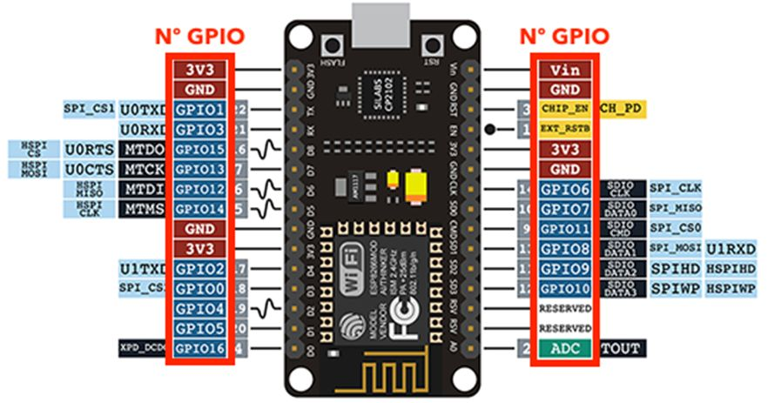

Power Pins There are four power pins viz. one VIN pin & three 3.3V pins. The VIN pin can be used to directly supply the ESP8266 and its peripherals, if you have a regulated 5V voltage source. The 3.3V pins are the output of an on-board voltage regulator. These pins can be used to supply power to external components.

GPIO Pins ESP8266 NodeMCU has 17 GPIO pins which can be assigned to various functions such as I2C, I2S, UART, PWM, IR Remote Control, LED Light and Button programmatically. Each digital enabled GPIO can be configured to internal pull-up or pull-down, or set to high impedance. When configured as an input, it can also be set to edge-trigger or level-trigger to generate CPU interrupts.

Control Pins are used to control ESP8266. These pins include Chip Enable pin (EN), Reset pin (RST) and WAKE pin.

* EN pin – The ESP8266 chip is enabled when EN pin is pulled HIGH. When pulled LOW the chip works at minimum power.
* RST pin – RST pin is used to reset the ESP8266 chip.
* WAKE pin – Wake pin is used to wake the chip from deep-sleep.

**GND** is a ground pin of ESP8266 NodeMCU development board.

D0 to D8 are general purpose I/O pins.

D0/GPIO16 pin can be only used as GPIO read/write, no special functions are supported on it.

A0 pin:

To read an analog signal through the NodeMCU, Analog to Digital conversion is required. A NodeMCU has 10 bit ADC which means it scales an analog signal in a range of 0-1023.

we read the analog value by using the analogRead() function and passing the analogInPin, A0 as an argument.